ECE 441 Fall 2021

WEEK #7 GROUP MEETING LOG

Lab Session: 2

Group Number: 2

Instructor: Dr. Jafar Saniie

Due Date: 03-02-2022

Acknowledgment: I acknowledge all of the work (including figures and codes) belongs to me and/or persons who are referenced.

Member 1: Alan Palayil

Member 2: Fabian Garcia

Member 3: Gabriel Gutierrez

[Smart Mirror - *Through the Speculum*]

**Project Goal:**

* Create an interactive smart mirror with gesture control, voice commands, and possibly facial recognition.
* Include accessories like LED strips and a sound system.
* Design a compacted design for the 24inch display

**Standards used in Project:**

Not applicable during this stage of the project

**System Constraints:**

* Xbox Kinect is meant for windows/microsoft devices; however, some additional libraries can be installed to the raspberry pi to help run this device.
* There is currently no operational wake engine for alexa voice services

**Prior Knowledge Acquired Critical to Design Project:**

ECE 100, ECE 211, ECE 213, ECE 218, ECE 242, ECE 307, ECE 308, ECE 311, ECE 319, ECE 407, ECE 411, ECE 436, ECE 438, ECE 485, CS 115, CS 116, CS 330, CS 331, CS 350, CS 351, CS 450

Note: CS 331- Data Structures and Algorithms (Python Programming)

Meeting 1

| Date | 2/27/2022 |
| --- | --- |
| Start Time | 1:00 PM |
| Duration | 1 hour |
| Attendance | All attended |

1. **Agenda**

The purpose of this meeting was to complete the final iteration of the component list

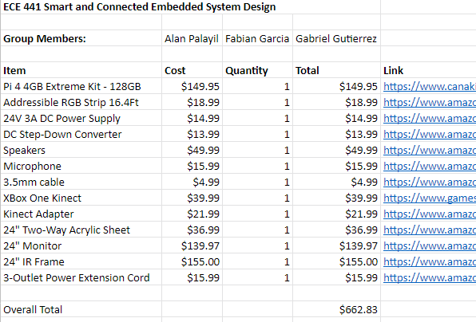

After successfully presenting the proposal the team was able to submit a component list for purchase.

1. **Tasks**

| **1 - Idea development** | | |
| --- | --- | --- |
| **Task** | **Assigned to** | **Due Date** |
| Finalize the components | Team | Completed |
| Submit the component list | Team | Complete |
| Work on OpenCV | Fabian and Gabriel | 3/7 |
| Work on Voice Wake | Alan | 3/14 |
|  |  |  |

1. **Work Distribution**

| **Alan Palayil** | Researched on wake engine and Alexa integration. |
| --- | --- |
| **Fabian Garcia** | Work on OpenCV and begin implementation. Become familiar with it |
| **Gabriel Gutierrez** | Reinstall OpenCV and see implementations of a regular webcam. |

1. **Progress and Milestones**

We finalized and submitted our components list to the ECE department in order to begin receiving our components for construction and implementation.

1. **Next Steps**

Meeting 2

| Date | 3/02/2022 |
| --- | --- |
| Start Time | 12:00 PM |
| Duration | 1.5 hours |
| Attendance | All attended |

1. **Agenda**

Talk about all the features we can add:

*Photobooth/Snapchat filter*

This lense filter would make the smart mirror more interactive

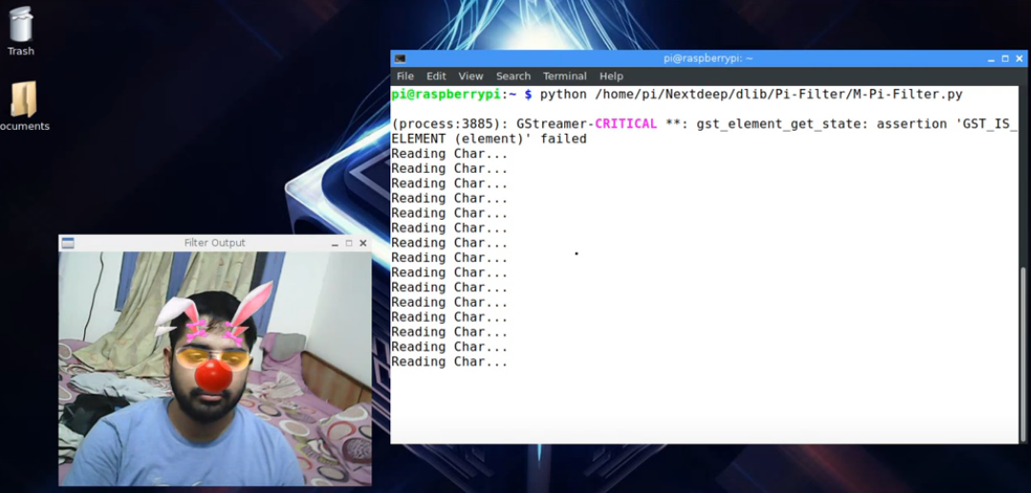

Example 1: Filter (<https://github.com/abhiTronix/OpenCV_Raspberry_pi_TBB>)

Requirements:

1. Camera module
2. OpenCV

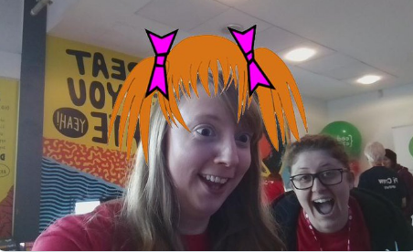

Example 2: Photobooth: (<https://www.raspberrypi.com/news/all-seeing-pi-photo-booth/>)

There are various way to implement this design; however, the team would have to take the camera only route since the finalized component list has already been sent out.

*Workout Video Streaming*

Can possibly use reminders or a checklist for a predetermined workout routine where the user goes through the workout on their own where each workout is on a timer.

Required:

1. Reminders or To Do List
2. Possible program to randomize a set of workouts that can be done at home within a certain period of time depending on the specific muscle groups desired or specific goals.
3. **Tasks**

| **2 - Software development** | | |
| --- | --- | --- |
| **Task** | **Assigned to** | **Due Date** |
| OpenCV | Everyone | 3/7 |
| Research on Workout APIs | Everyone | 3/5 |
| Photobooth Research | Everyone | 3/5 |
| Await components | Professor Won-Jae Yi | TBD |
|  |  |  |

1. **Work Distribution**

| **Alan Palayil** | Looked at app development for magic mirror modules to make custom modules for face, clothes, background filters. |
| --- | --- |
| **Fabian Garcia** | Get OpenCV working on Raspberry Pi 4 and Begin implementation with a webcam. If working, begin looking at gestures. |
| **Gabriel Gutierrez** | Continue fixing the issues that arise with OpenCV on the Raspberry Pi 3.  Look into current iterations of a raspberry pi photobooth. |

1. **Progress and Milestones**

We brainstormed additional features that we could add to the mirror to make it more immersive and fun. Ultimately giving the mirror more uses than just a mirror with a touchscreen and a speaker.

1. **Next Steps**

Main Focus from here moving forward, until we acquire the hardware would be on the software set up and implementation of OpenCV specifically. With the implementation of OpenCV we can begin experimenting with the gesture controls as well as the photobooth feature and the workout aspect of the mirror.